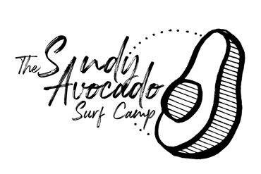

Registration & Hold Harmless Agreement
STEFFMAGS LLC dba The Sandy Avocado Surf Camp

Please circle one of the following:

Single Day: $100

Full Week: $350

Private Lesson: $80

Full Season: $2,500

Student’s Name (please print) _________________________________________
Student’s Birthday
Age :______________
Address: ________________________________ Town, State: ____________________
Zip Code: ________
How did you hear about us?
Equipment (check one): ( ) Has Board ( ) Needs Board
Skill Level (check one): ( ) Novice ( ) Intermediate ( ) Advanced
Shirt Size:
Parent/Guardian Name: ____________________________________________
Email: ______________________________________
Phone:
AGREEMENT between Steff Mags LLC and
Student’s Name: ___________________________
Parent/Guardian’s Name: ________________________
IF STUDENT IS UNDER 18 YEARS OF AGE, PARENT OR GUARDIAN MUST SIGN… NO EXCEPTIONS!
I, ___________________________________, being an adult, (or a minor on whose behalf a parent or legal guardian is signing this document) certify that I (or the minor school participant) can swim and acknowledge inherent risks of swimming and board sports in the ocean and potential injuries that may result by participating in water board sports. I agree to hold harmless STEFF MAGS LLC from all claims of liability which causes me (or the minor school participant) damages of any nature in any way connected with participation in this activity. I also expressly agree to release and discharge STEFF MAGS LLC from any act or omission in rendering or failing to render any type of rescue, emergency or medical services. I further agree, to hold harmless STEFF MAGS LLC, and the CITY, or TOWN IN WHICH THE LESSONS ARE PERFORMED from all defense costs, including attorney's fees incurred in connection with any claims arising from the activities that take place herein, whether caused by or sustained by any minor under 18 years of age on whose behalf I am signing, or which I may have caused to spectators or other third parties, whether negligent or not, in the course of my participation in this activity. I consent to the use of a 10x10 pop up tent during operational hours and release STEFF MAGS LLC, the CITY, and TOWN IN WHICH THE LESSONS ARE PERFORMED any inherent risks associated with the use of this object. I also authorize LBI SKIM CAMP, THE SANDY AVOCADO SURF CAMP under STEFF MAGS LLC to use any photos or video taken of the minor whom I am signing for social media and advertisements.
Signature: _______________________________________________________
Date: __________________

